or technology – for the glory of God. It is about offering our treasures, giving a proportional and sacrificial portion of our income, recognizing that all we have comes from God.
We can rise up and build the wall of Christian love, seeing Christ in all people, forgiving with patience, and compassion. In Christian love, we serve those in need, both within and outside our parish family, in our neighborhood and around the world.
To rise up requires effort, dedication, and perseverance. Building and rebuilding is not easy. But when we commit ourselves fully and sacrificially, God will bless our efforts.
The story of Nehemiah reminds us that stewardship is not only a financial obligation; it is a response of gratitude and love to God for His blessings. It is about actively participating in the ongoing work of building up the Kingdom of God, starting with the walls of our own souls and extending to the life of our parish and the world around us.

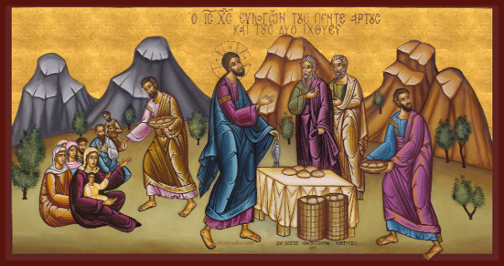
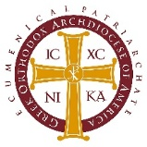
Stewardship Ministries

iconography: afentoulis.com
for reflection…

Building Up the Body of Christ
Ephesians 4:11-16 (NIV)
It was he who gave some to be apostles, some to be prophets, some to be evangelists, and some to be pastors and teachers, to prepare God’s people for works of service, so that the body of Christ may be built up until we all reach unity in the faith and in the knowledge of the Son of God and become mature, attaining to the whole measure of the fullness of Christ.

Then we will no longer be infants, tossed back and forth by the waves, and blown here and there by every wind of teaching and by the cunning and craftiness of men in their deceitful scheming. Instead, speaking the truth in love, we will in all things grow up into him who is the Head, that is, Christ. From him the whole body, joined and held together by every supporting ligament, grows and builds itself up in love, as each part does its work.

Parish information here.
Include QR code to online giving.


Rise Up
build
Nehemiah 2:18
Building
Up
the
Body
of
Christ
and
“RISE UP AND BUILD”
Nehemiah 2:18

Building Up
the Body of Christ
In the Old Testament we read about Nehemiah. After seeing the crumbling walls of Jerusalem, he called the people to “Rise up and build." Nehemiah doesn't do it alone. He inspires the people, sharing his vision. And the response of the people? "Let us rise up and build."
This story and the words of Nehemiah (2:19) call us today, not just to building and rebuilding with bricks and mortar, but also to a deeper, spiritual building – the rebuilding and renewal of our faith. As Orthodox Christians, we are called to respond to God's gifts with faithful stewardship. Like Nehemiah, we are called to "rise up and build," carrying on God’s work in our parish our community and in the world.
This call of Nehemiah to "rise up and build" invites us to become active members of the Church, the Body of Christ, to join in ministry and contribute according to our abilities. As Orthodox Christians, we understand that stewardship is a joint effort of all the members of the community. Every member has a role to play.
how much is it?
Stewardship is not a matter of “how much is it?” or “how much is needed?” Stewardship and generosity are aspects of spiritual discipline and an indication of our spiritual maturity. In stewardship we acknowledge that all we have is a gift from God and we are to use His gifts in ways that honor Him. This transforms our understanding of the blessings in our life. It prompts us to use our blessings for the good of others and for the glory of God.
Just as the walls of Jerusalem were broken through neglect or indifference, a neglected spiritual life can also become dilapidated and broken. The words of Nehemiah call us to renew and rebuild our commitment to our faith, and our dedication and support for our Church and her ministries.
compassion and faith
Nehemiah's response is a great example for us. He was moved by compassion and faith. He saw the need, and his heart was stirred. He didn't ignore the problem; he embraced it as his own. This is the first step in true stewardship: seeing the needs of God's Church and responding with love and sacrifice.
Nehemiah prayed. Before any action, Nehemiah turned to God. He understood that true rebuilding, both physical or spiritual, begins and ends with God. Stewardship is not about our own strength, but about God working through us.
practical and intentional
Nehemiah planned and acted. Prayer without action is just empty words. Nehemiah meticulously planned, secured resources, and then courageously led the work. Stewardship is practical; it is intentional, requiring wise planning, and diligent use of our God-given abilities and resources.
Nehemiah inspired others. He didn't just command. He shared his vision. He ignited a spark in the hearts of the people, reminding them of their importance in this process. This is crucial for our parish stewardship ministry. We lead by example, inspiring one another to participate, to offer their unique gifts for the good of our Church.
This is our call today. We are called to be like Nehemiah in our own lives and in our parish.
We can rise up and build the walls of prayer by dedicating time each day to personal prayer, Scripture reading, and participation in the liturgical life of the Church.
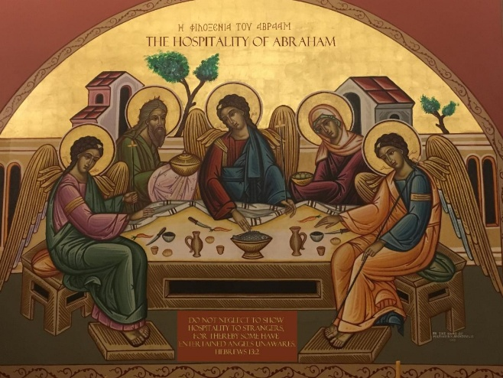
receive the presence of Jesus
We can rise up and build the walls of worship by being present in Divine Liturgy, offering our time, our worship and our gratitude for His blessings. We offer our whole being to God in worship, and we receive the presence of Jesus Christ within us.
We can rise up and build the wall of generosity. Stewardship is not just about money, though it is vital for our Church's mission. Stewardship is offering our time, serving in ministries, being ready to help, wherever we are needed. It is about offering our talents and our unique skills – whether in music, administration, hospitality,

